Digital Badge and Entrepreneurial Competences

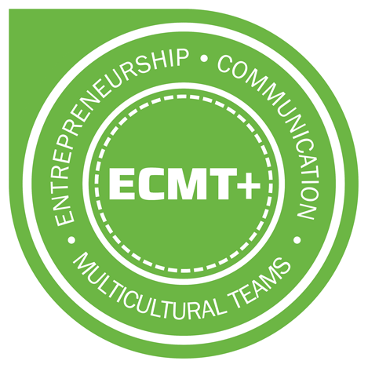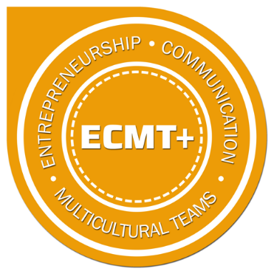

In the ECMT+ project the use of a digital badge was explored in order to make learners’ personal skills and competencies more visible. As digital badges can be shared in online social networks they are more easily accessible for the employers than traditional certificates. The development work started with defining the key entrepreneurial competencies relevant to our intensive programme:
The student has proved that she/he has the skills to:
- Work in an international team of students from different cultural backgrounds.
- Use their creativity to brainstorm and develop a convincing, innovative business plan.
- Communicate their own ideas clearly and persuasively.
- Evaluate and negotiate different proposals and suggestions from other team players.
- Approach problems from a variety of perspectives and develop workable solutions.
- Test how practical and robust a prototype proves to be.
- Keep tight deadlines throughout a two-week intensive programme.
- Present a business plan in a team to a panel of experts and answer tough questions.
- Reflect on their experience and personal development with their team throughout the intensive course.
The next step was to create the criteria for receiving the badge to support to aims of the Intensive programme.

Requirements for receiving the ECMT+ Digital Badge are:
- successful participation in the course preparation phase.
- successful participation in the intensive weeks and final pitch.
- submission of a self-reflective essay.
Designing the learning objectives and criteria for the badge are aligned with the underlying understanding of what the required skills and competencies in entrepreneurial education currently are.

We additionally launched a more advanced badge, Golden Badge, for which the participants filled in an application form and attached evidence of their gained skills and competences.
During the ECMT+ project in 2017-2019 there were 128 students from the seven project partners participating in the annual intensive programmes. The green badge was awarded to 80 students and there were 6 students who were awarded the golden badge.
Challenges

The concept of digital credentialing is still very new both to teachers and students, not to mention the employers. But with the growing shift towards competence- based education, online courses and independent professional development there is a clear need and potential for digital credentialing.

